MANUAL FOR EVALUATION INSTRUMENT OF COPPA 2nd Edition (2017)

STEP 1: “Enable Macro”

Click the button “Enable Content”, for the file to function fully (if the following window is shown)

To begin filling in information, please click the “START” button.

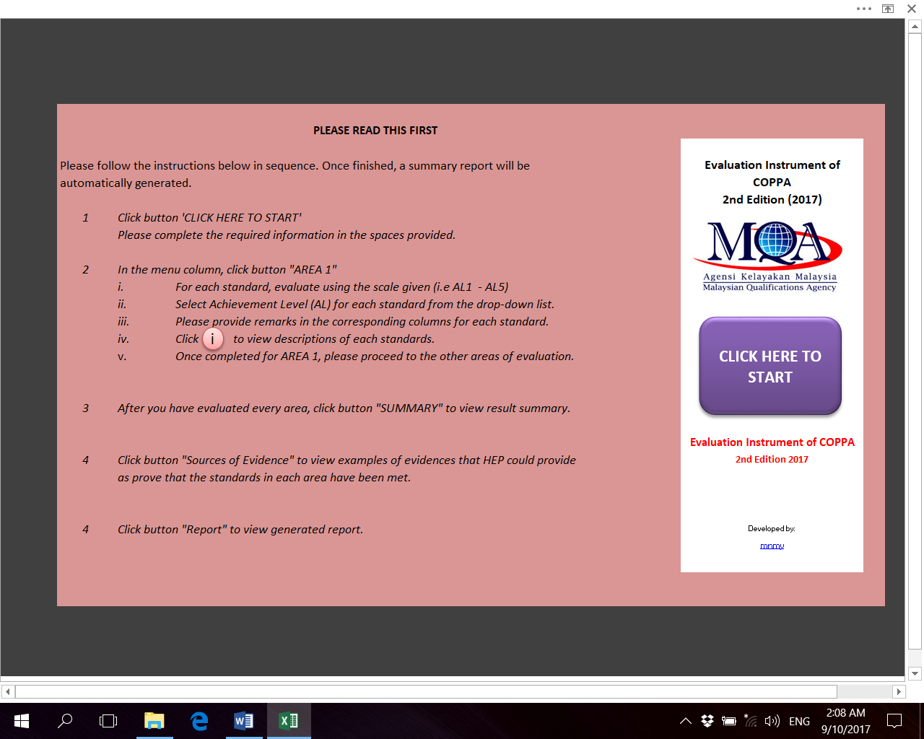

STEP 2: Completing accreditation information.

You will be asked whether you want the current data to be deleted. If you click “YES”, all data will be deleted.
Please provide the information required, then click “NEXT” button in the menu bar on the upper right-hand side of the screen.

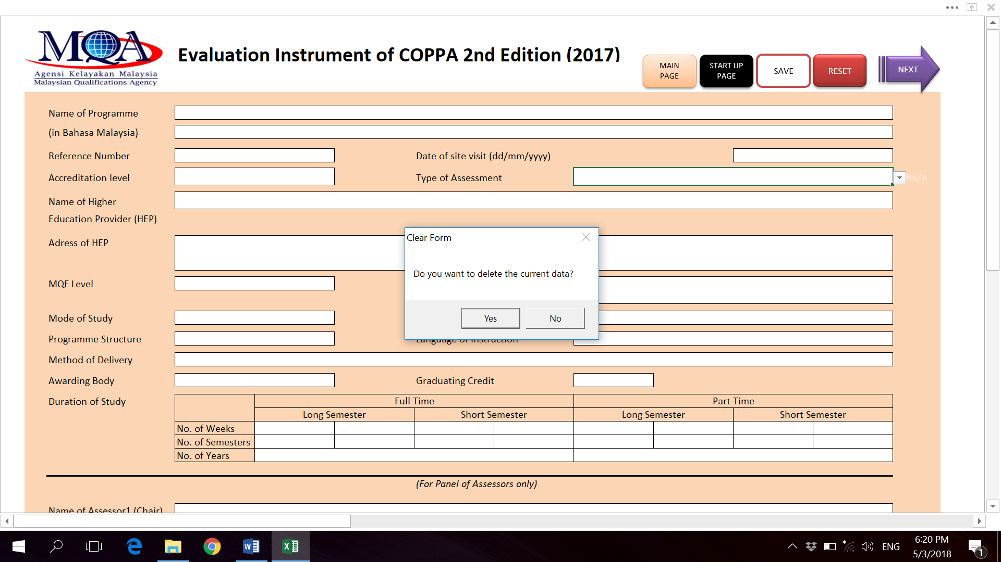

For Provisional Accreditation:
MQA Panel of Assessor (POA)
Click “Type of Assessment”
Choose “MQA POA PA Evaluation Report”
In MS Excel menu:
FILE > Save As > (e.g.
“MQA POA UFM PA1234”

HEP submit Evaluation Instrument (UFM PA1234) with MQA-01
Higher Education Provider (HEP)
Click “Type of Assessment”
Choose “HEP Input (PA)”
In MS Excel menu:
FILE > Save As > (e.g.
“UFM PA1234”

MQA POA submit Evaluation Instrument (MQA POA UFM PA1234) to MQA

For Full Accreditation:

Higher Education Provider (HEP)
Click “Type of Assessment”
Choose “HEP Self Review Report”
In MS Excel menu:
FILE > Save As > (e.g.
“UFM FA1234”
MQA Panel of Assessor (POA)
Click “Type of Assessment”
Choose “MQA POA Preliminary FA Evaluation Report”
In MS Excel menu:
FILE > Save As > (e.g.
“MQA POA UFM FA1234”
HEP submit Evaluation Instrument (UFM FA1234) with MQA-02
MQA POA submit Evaluation Instrument (MQA POA UFM FA1234) to MQA

SITE VISIT
MQA Panel of Assessor (POA)
Click “Type of Assessment”
Choose “MQA POA Post Visit FA Evaluation Report”
In MS Excel menu:
FILE > Save As > (e.g.
“MQA POA UFM FA1234 Post Visit”
MQA POA submit Evaluation Instrument (MQA POA UFM FA1234 Post Visit) to MQA

STEP 3: Evaluating the Seven Area of Evaluation

For a programme to be accredited, all standards must be complied with, minimum at Attainment Level (AL) 3. Achieving AL2 and AL1 results in an outright denial of accreditation and warrants serious attention of the institution on the viability of the programme.

For each ‘AREA’, please evaluate each ‘standard’ according to the ‘Achievement Level (AL)’ from the drop-down list. The ‘AL Descriptor’ will automatically appear, once an AL is selected. You have to provide remarks in the spaces provided for ‘Strength/ Commendation’, ‘Steps taken to maintain and enhance the strengths’, ‘Areas of concern/ Weakness/ Condition’ and ‘Steps taken to address the problem areas’.
Remarks by panel of assessors under ‘Areas of concern/Weakness/Condition’ will be taken as conditions and HEP will need to rectify these conditions (in a given period of time) in order to be granted accreditation.
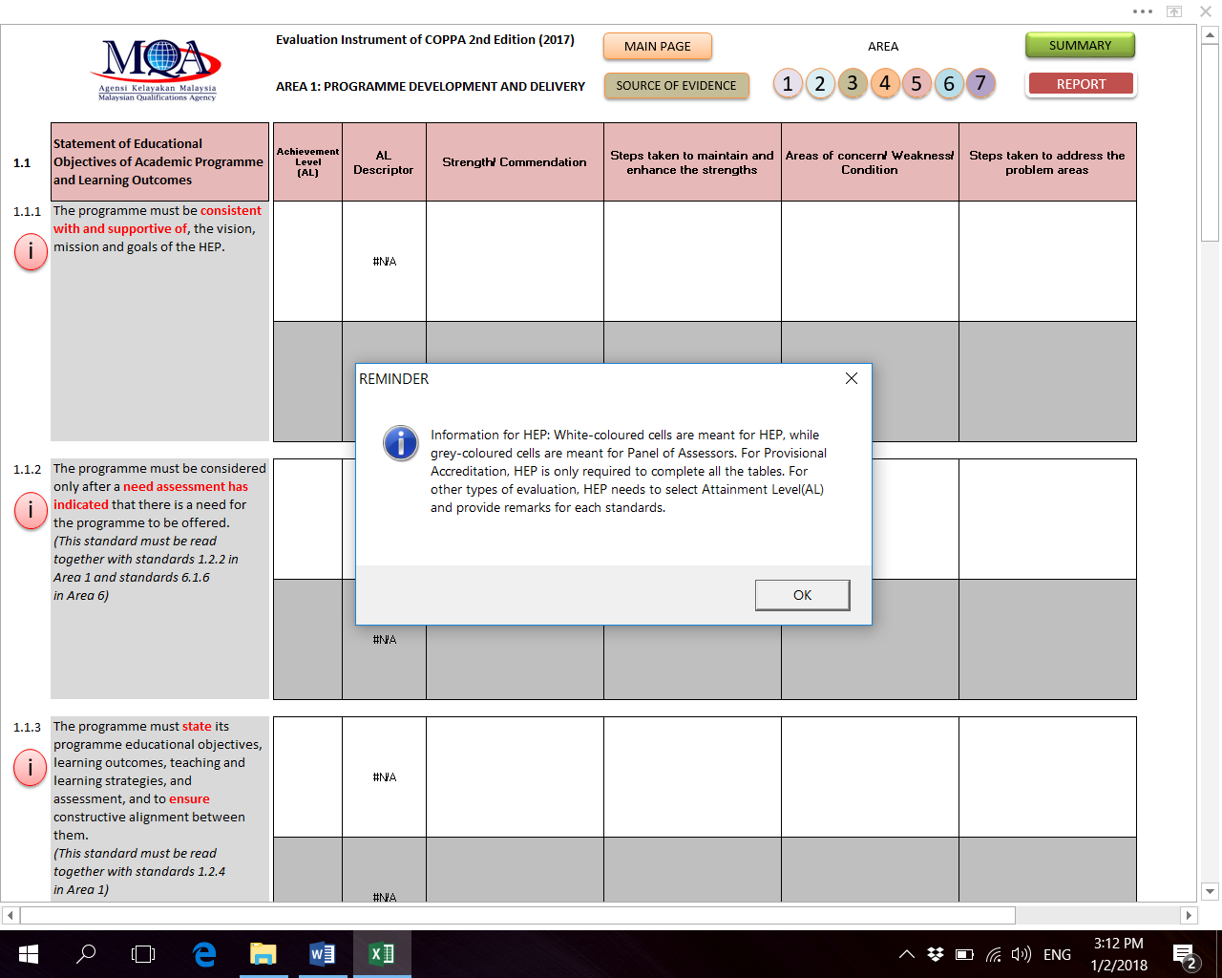

If there are no remarks in any of the spaces, “INPUT ERROR! Please provide remarks” will appear underneath the standard.
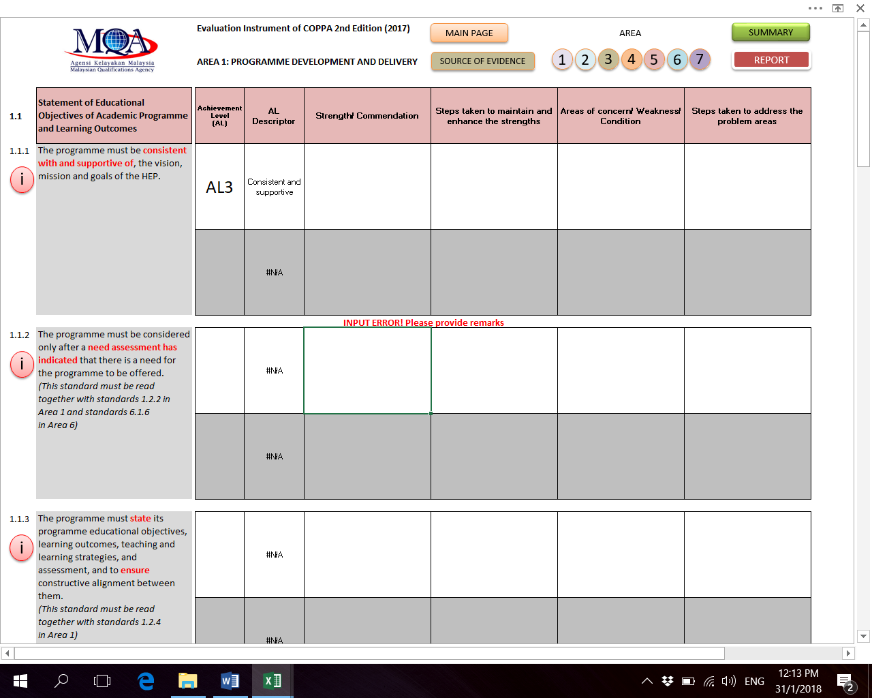

There will also be “ERROR” in the “SUMMARY” if these reminders still appear. It must be ensured that the comment space(s) is/are filled in.
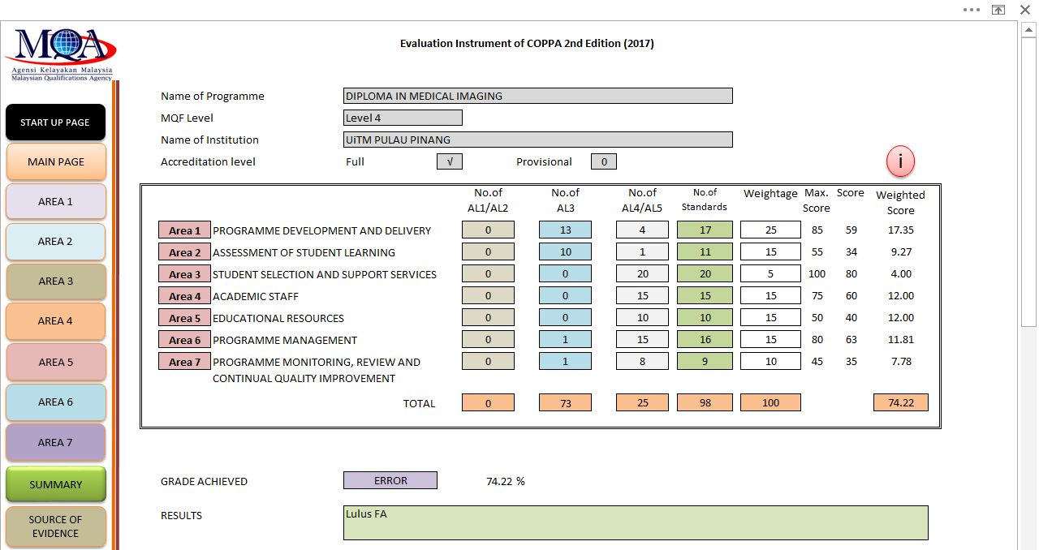

The user will also need to complete the required tables (i.e. Table1 -3, Table 5-8) in the instrument. Click the “Table” buttons to complete the tables. User may copy and paste tables prepared in MQA-01 and MQA-02 forms into this instrument.

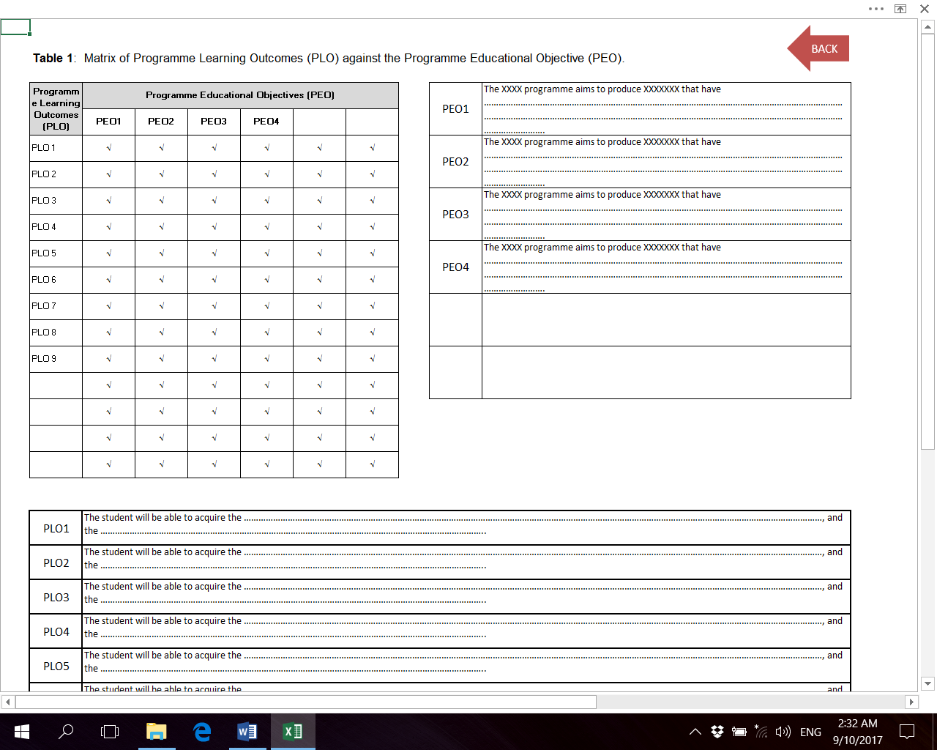

You can click to view information on how to comply with the standards. Once you have completed ‘AREA 1’, please proceed to other ‘AREA’ by clicking the buttons in the menu bar.

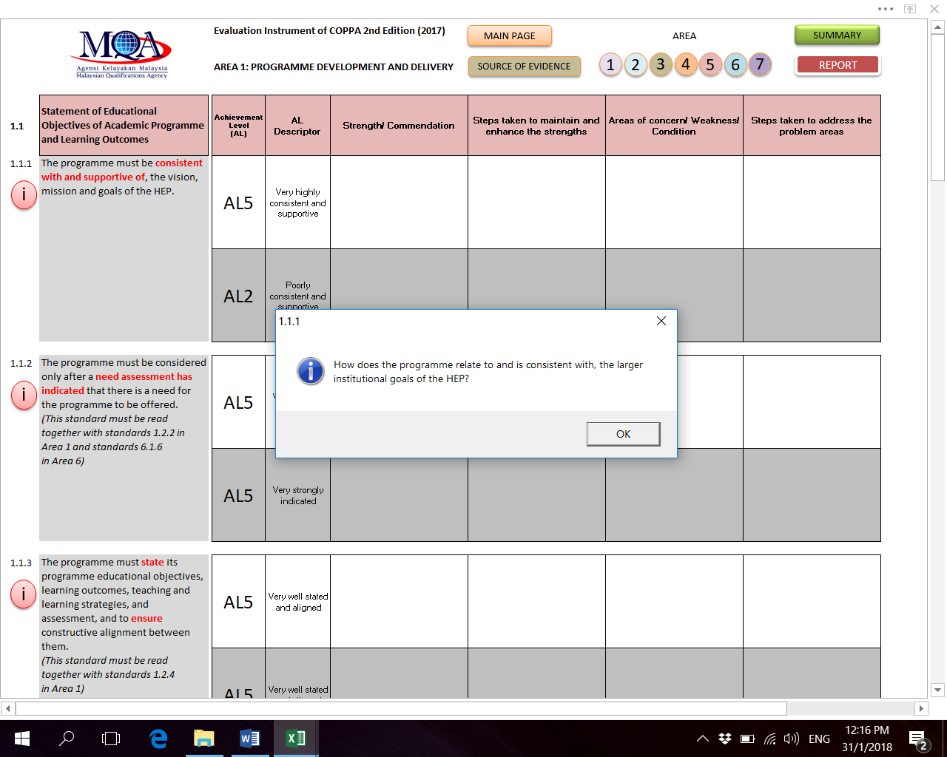

You can also click the button “SOURCE OF EVIDENCES” to view some suggestions on how to provide evidences for standards in each Area.

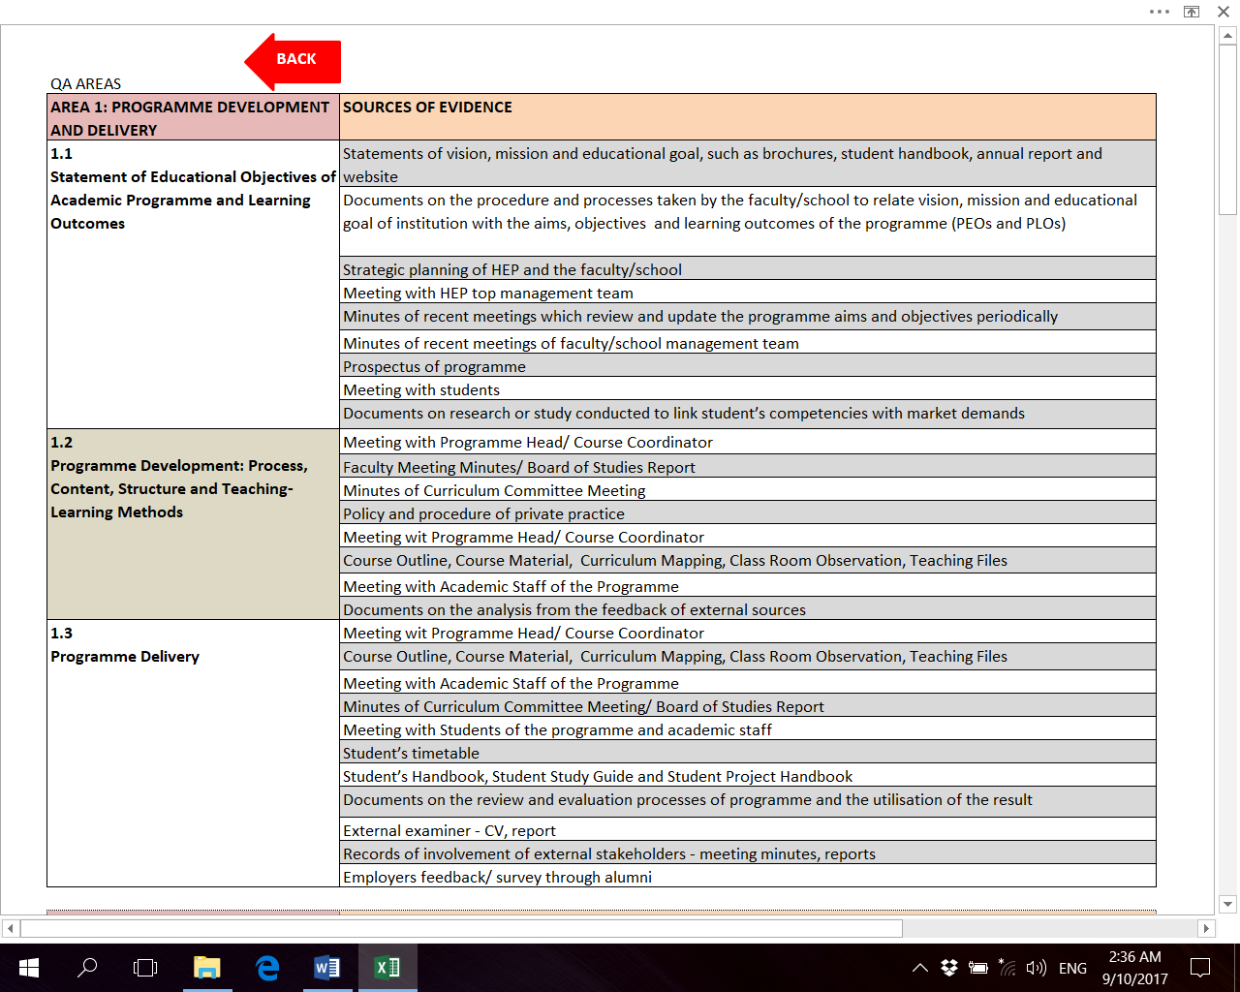

STEP 4: Generating the summary of evaluation

The evaluation summary will be automatically generated. User can click “SUMMARY” button to view.

Weightage (%) for each Area:

Area | PA | FA
Area1 | 40% | 25%
Area2 | 10% | 15%
Area3 | 5% | 10%
Area4 | 15% | 15%
Area5 | 15% | 15%
Area6 | 10% | 10%
Area7 | 5% | 10%

The weightage is applied to the sum of AL achieved for every Area. Example:

 | No. of STD | No. of STD according to AL |  |  |  |  |  | No. of STD according to AL |  |  |  |  | Max  Scr | Actual Scr | PA* | FA*
 |  | AL5 | AL4 | AL3 | AL2 | AL1 |  | AL5 | AL4 | AL3 | AL2 | AL1
AREA1 | 17 | 2 | 0 | 15 | 0 | 0 |  | 10 | 0 | 45 | 0 | 0 | 85 | 55 | 25.88 | 16.18
AREA2 | 11 | 0 | 1 | 10 | 0 | 0 |  | 0 | 4 | 30 | 0 | 0 | 55 | 34 | 6.18 | 9.27
AREA3 | 20 | 0 | 20 | 0 | 0 | 0 |  | 0 | 80 | 0 | 0 | 0 | 100 | 80 | 4.00 | 8.00
AREA4 | 15 | 0 | 15 | 0 | 0 | 0 |  | 0 | 60 | 0 | 0 | 0 | 75 | 60 | 12.00 | 12.00
AREA5 | 10 | 0 | 10 | 0 | 0 | 0 |  | 0 | 40 | 0 | 0 | 0 | 50 | 40 | 12.00 | 12.00
AREA6 | 16 | 0 | 15 | 1 | 0 | 0 |  | 0 | 60 | 3 | 0 | 0 | 80 | 63 | 7.88 | 7.88
AREA7 | 9 | 0 | 9 | 0 | 0 | 0 |  | 0 | 36 | 0 | 0 | 0 | 45 | 36 | 4.00 | 8.00
 |  |  |  |  |  |  |  |  |  |  |  |  |  |  | 71.94 | 73.32

Note:
* Percentage for each Area = (Actual Score / Max Score) * Weightage
NOTE ON GRADING SYSTEM
The grading system assists panel of assessors and also HEP in making overall quantitative judgment on the quality of a programme. The grading system comprises of six Grades, each indicating different achievement level of accreditation based on the standards fulfilment in seven areas of evaluation, resulting in granting or refusing Full Accreditation. No grade is given for Provisional Accreditation.
GRADE | ACHIEVEMENT INDICATOR | RESULT
A | 80%  (Achieve 100% AL3 and above) | Pass FA
B⁺ | 70%  (Achieve 100% AL3 and above) | Pass FA
- | 70%  (Achieve 100% AL3 with conditions) | FA is considered after all conditions (areas of concern) are met
B | 70%  (Achieve 100% AL3 without conditions) | Pass FA after areas of concern are rectified
C⁺ | 60%  (Achieve 100% AL3 and above) | Pass FA
- | 60%  (Achieve 100% AL3 with conditions) | FA is considered after all conditions are met
C | 70%  (Achieve 100% AL3 without conditions) | Pass FA after areas of concern are rectified
F | Not achieving 100% AL3 | Refuse FA
Note:
- Percentage stated in Achievement Indicator is the result of Accreditation evaluation.
- No grade is given if a programme is considered (areas of concern to be addressed) for Accreditation. Grade will be given once all the areas of concern in the programme are rectified.

STEP 5: Generating the report

The REPORT is automatically generated once all the information has been provided accordingly AND it is ONLY functional to generate assessors’ reports.

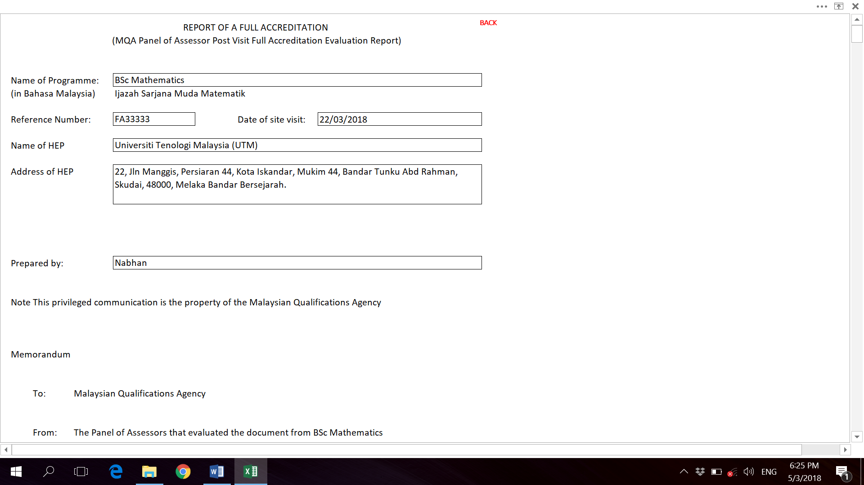

User can go back to the “MAIN PAGE” by clicking “BACK” in the “REPORT” document.

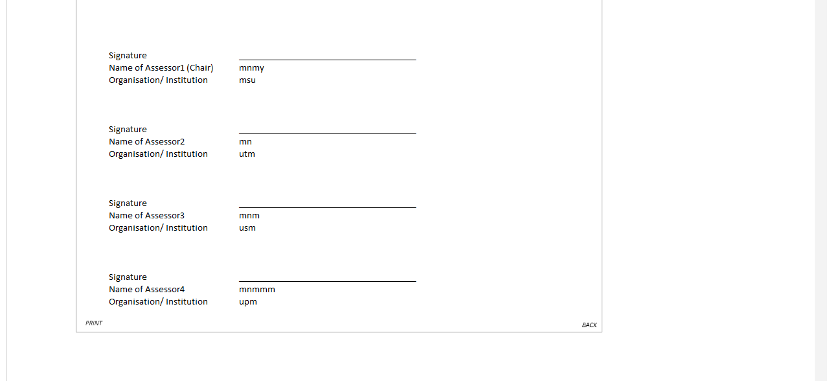

PRINTING THE REPORT:

Click “PRINT” in the report to print the document. The report can also be printed like any normal MS Excel “worksheet”.

